Square
# Source: AI Source: Provided by: [Data Path: Persons Table -> ID Column: 1, Name_En Column: Motasem Essam] -> From: [ChatGPT] on [7/25/2026]
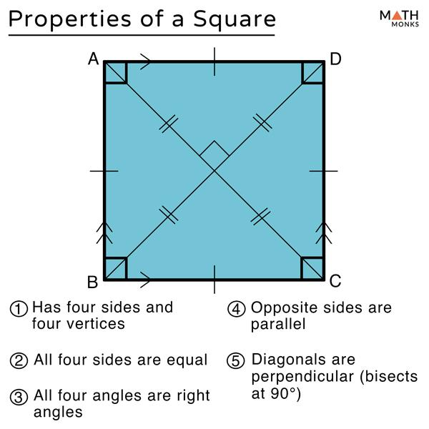
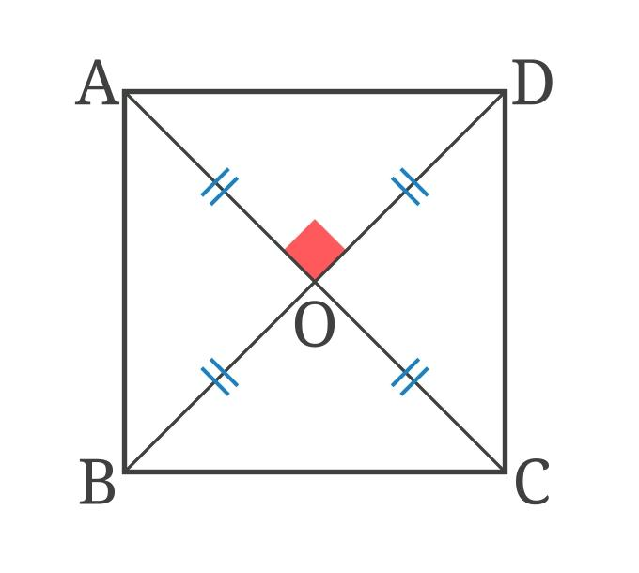
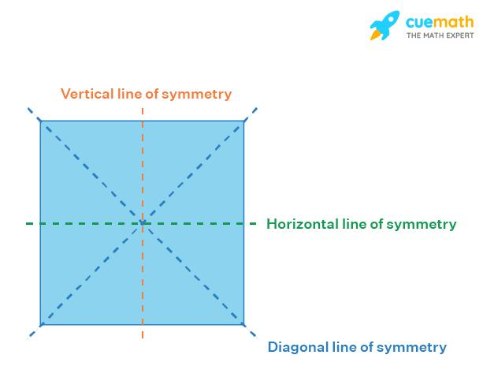
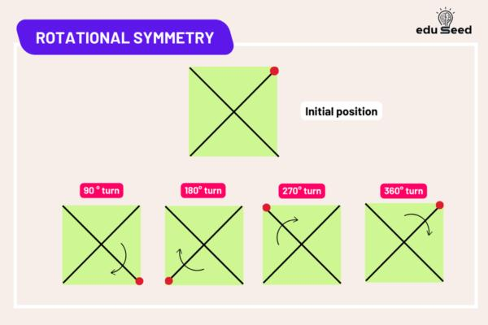
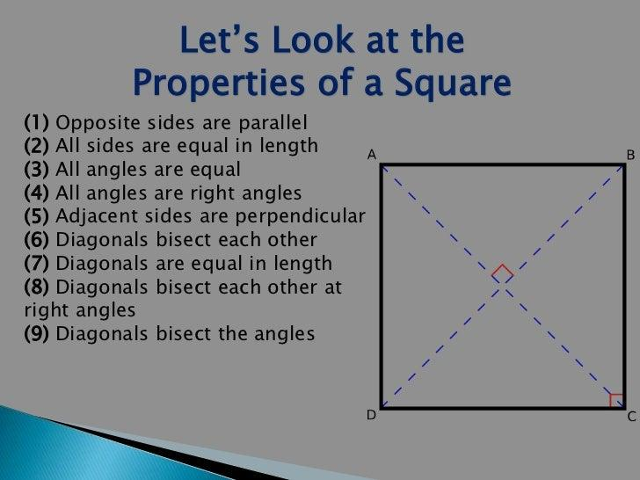

Definition
# Source: AI Source: Provided by: [Data Path: Persons Table -> ID Column: 1, Name_En Column: Motasem Essam] -> From: [ChatGPT] on [7/25/2026]
A square is a quadrilateral with four congruent sides and four right angles.
For square $ABCD$:
$$AB=BC=CD=DA$$
and
$$∠A=∠B=∠C=∠D={90}^{∘}$$
A square is a special type of both a rectangle and a rhombus.
$$\boxed{\text{Square}=\text{Rectangle}+\text{Rhombus}}$$

Purpose
# Source: AI Source: Provided by: [Data Path: Persons Table -> ID Column: 1, Name_En Column: Motasem Essam] -> From: [ChatGPT] on [7/25/2026]
The square is used to:
- Study relationships between equal sides and right angles.
- Calculate perimeter and area.
- Study diagonals and symmetry.
- Understand special properties of quadrilaterals.
- Model regular geometric shapes.
- Form the basis of many constructions and geometric designs.

Fundamental Elements
# Source: AI Source: Provided by: [Data Path: Persons Table -> ID Column: 1, Name_En Column: Motasem Essam] -> From: [ChatGPT] on [7/25/2026]
Consider square $ABCD$.
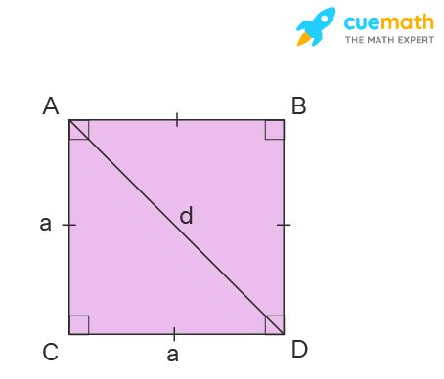
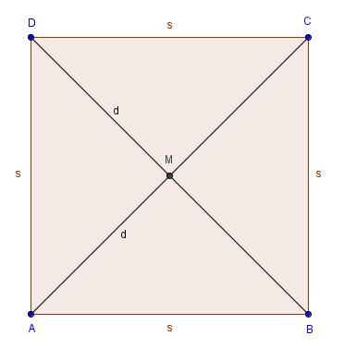
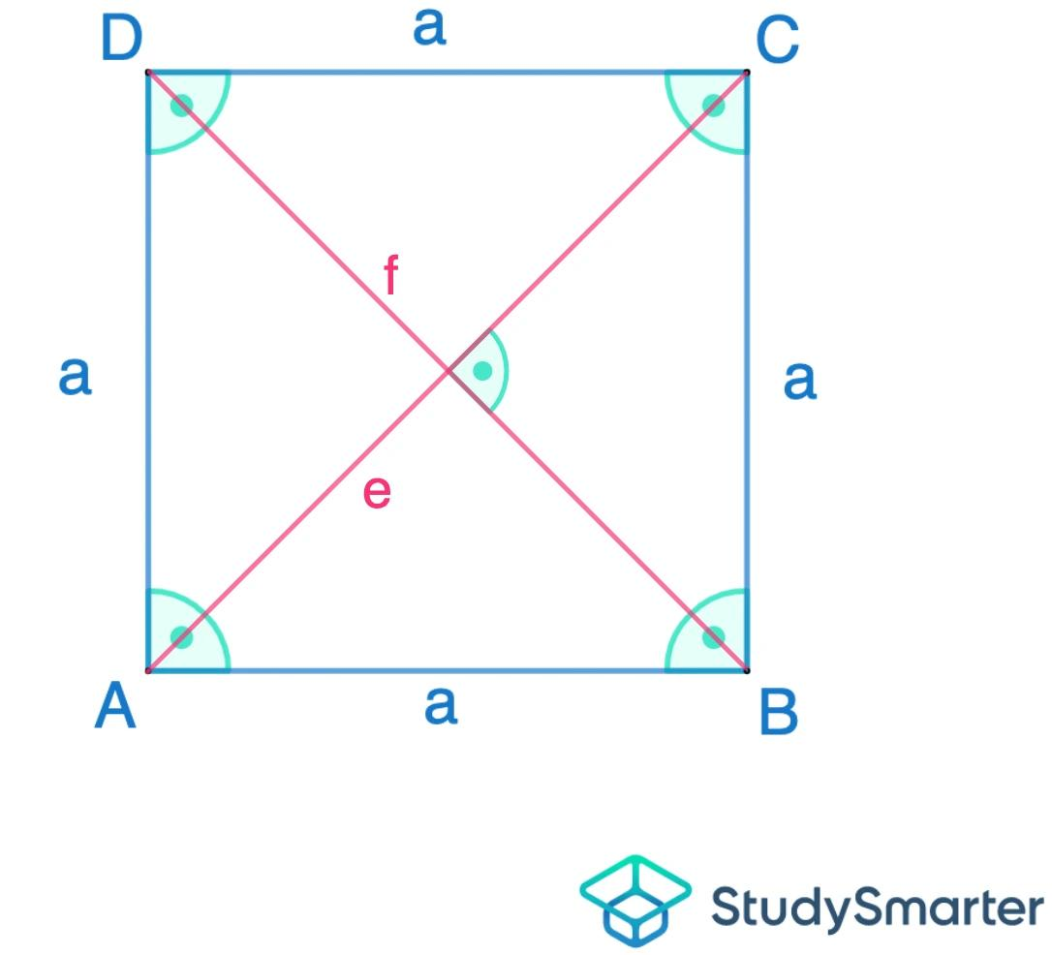
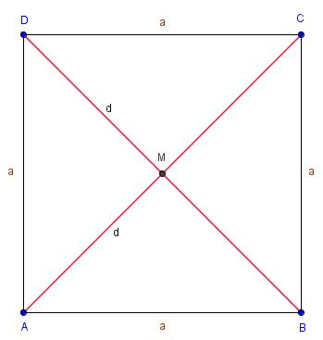

1. Sides
# Source: AI Source: Provided by: [Data Path: Persons Table -> ID Column: 1, Name_En Column: Motasem Essam] -> From: [ChatGPT] on [7/25/2026]
The four sides are:
$$\overset{‾}{AB}, \overset{‾}{BC}, \overset{‾}{CD}, \overset{‾}{DA}$$
All four sides are congruent:
$$\boxed{AB=BC=CD=DA}$$

2. Vertices
# Source: AI Source: Provided by: [Data Path: Persons Table -> ID Column: 1, Name_En Column: Motasem Essam] -> From: [ChatGPT] on [7/25/2026]
The four vertices are:
$$A, B, C, D$$

3. Interior Angles
# Source: AI Source: Provided by: [Data Path: Persons Table -> ID Column: 1, Name_En Column: Motasem Essam] -> From: [ChatGPT] on [7/25/2026]
Every interior angle is a right angle:
$$\boxed{{90}^{∘}}$$
Therefore:
$$∠A=∠B=∠C=∠D={90}^{∘}$$

4. Diagonals
# Source: AI Source: Provided by: [Data Path: Persons Table -> ID Column: 1, Name_En Column: Motasem Essam] -> From: [ChatGPT] on [7/25/2026]
The diagonals are:
$$\overset{‾}{AC}$$
and
$$\overset{‾}{BD}$$

5. Center
# Source: AI Source: Provided by: [Data Path: Persons Table -> ID Column: 1, Name_En Column: Motasem Essam] -> From: [ChatGPT] on [7/25/2026]
The diagonals intersect at the center of the square.
If they intersect at $O$:
$$\boxed{AO=OC}$$
and
$$\boxed{BO=OD}$$

Defining Properties
# Source: AI Source: Provided by: [Data Path: Persons Table -> ID Column: 1, Name_En Column: Motasem Essam] -> From: [ChatGPT] on [7/25/2026]
A quadrilateral is a square if it has:
- Four congruent sides.
- Four right angles.
Therefore:
$$\boxed{AB=BC=CD=DA}$$
and
$$\boxed{∠A=∠B=∠C=∠D={90}^{∘}}$$
These are the fundamental defining properties of a square.

Square as a Regular Polygon
# Source: AI Source: Provided by: [Data Path: Persons Table -> ID Column: 1, Name_En Column: Motasem Essam] -> From: [ChatGPT] on [7/25/2026]
A square is a regular polygon because:
- All sides are equal.
- All interior angles are equal.
Since it has four sides, it is a:
$$\boxed{\text{Regular quadrilateral}}$$
Its interior angle is:
$$\frac{\left(4-2\right){180}^{∘}}{4}={90}^{∘}$$

Perimeter
# Source: AI Source: Provided by: [Data Path: Persons Table -> ID Column: 1, Name_En Column: Motasem Essam] -> From: [ChatGPT] on [7/25/2026]
If each side has length $s$, the perimeter is:
$$\boxed{P=4s}$$
Example
If:
$$s=8\text{ cm}$$
then:
$$P=4\left(8\right) \\ \boxed{P=32\text{ cm}}$$

Area
# Source: AI Source: Provided by: [Data Path: Persons Table -> ID Column: 1, Name_En Column: Motasem Essam] -> From: [ChatGPT] on [7/25/2026]
The area of a square is:
$$\boxed{A=s^{2}}$$
where $s$is the side length.
Example
If:
$$s=6\text{ cm}$$
then:
$$A=6^{2} \\ \boxed{A=36{\text{ cm}}^{2}}$$

Diagonals
# Source: AI Source: Provided by: [Data Path: Persons Table -> ID Column: 1, Name_En Column: Motasem Essam] -> From: [ChatGPT] on [7/25/2026]
The diagonals of a square have several special properties.
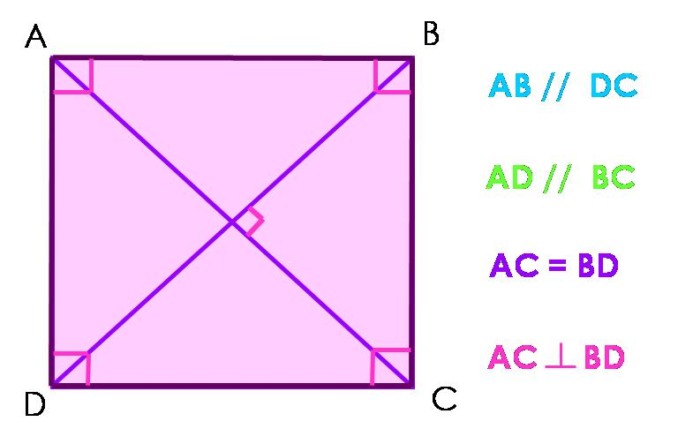
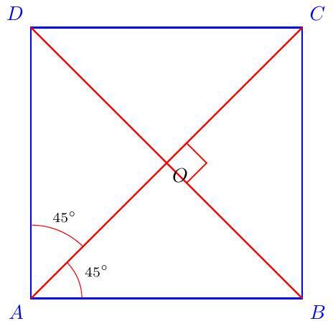
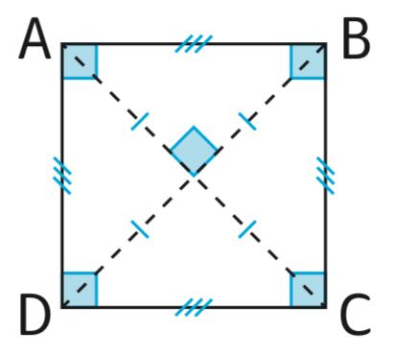
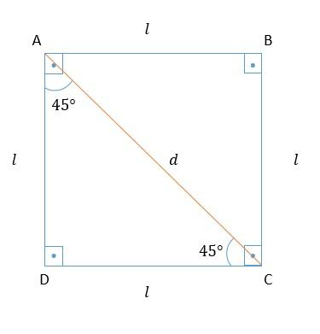
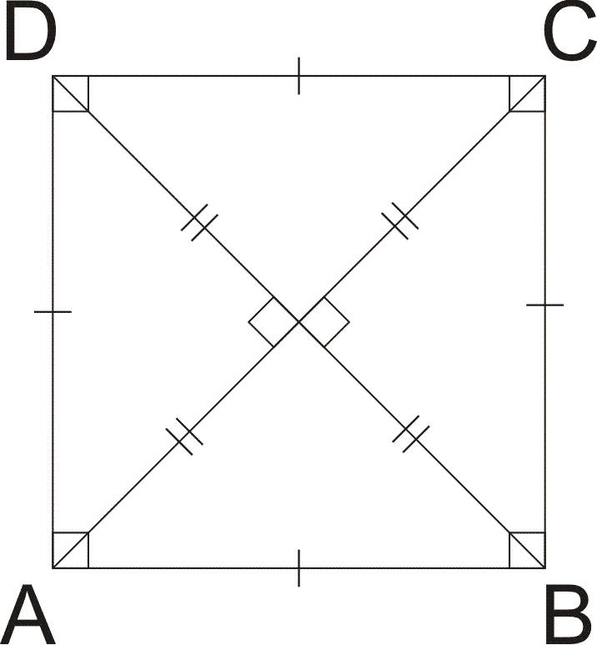
The diagonals:
- Are congruent.
- Bisect each other.
- Are perpendicular.
- Bisect the interior angles.
- Divide the square into four congruent right triangles.
Therefore:
$$\boxed{AC=BD}$$
and if they intersect at $O$:
$$\boxed{AO=OC} \\ \boxed{BO=OD}$$
and:
$$\boxed{AC⊥BD}$$

Diagonal Length
# Source: AI Source: Provided by: [Data Path: Persons Table -> ID Column: 1, Name_En Column: Motasem Essam] -> From: [ChatGPT] on [7/25/2026]
If the side length is $s$, the diagonal length is:
$$\boxed{d=s\sqrt{2}}$$
This follows from the Pythagorean Theorem.
For a square with side $s$:
$$d^{2}=s^{2}+s^{2} \\ d^{2}=2s^{2} \\ \boxed{d=s\sqrt{2}}$$
Example
If:
$$s=5\text{ cm}$$
then:
$$d=5\sqrt{2}\text{ cm}$$
Approximately:
$$\boxed{d≈7.07\text{ cm}}$$

Area Using the Diagonal
# Source: AI Source: Provided by: [Data Path: Persons Table -> ID Column: 1, Name_En Column: Motasem Essam] -> From: [ChatGPT] on [7/25/2026]
Since:
$$d=s\sqrt{2}$$
the area can also be expressed in terms of the diagonal:
$$\boxed{A=\frac{d^{2}}{2}}$$
Example
If:
$$d=10\text{ cm}$$
then:
$$A=\frac{{10}^{2}}{2} \\ A=\frac{100}{2} \\ \boxed{A=50{\text{ cm}}^{2}}$$

Angles and Diagonals
# Source: AI Source: Provided by: [Data Path: Persons Table -> ID Column: 1, Name_En Column: Motasem Essam] -> From: [ChatGPT] on [7/25/2026]
Each diagonal of a square bisects two opposite right angles.
Therefore, each diagonal creates:
$$\boxed{{45}^{∘}}$$
angles at the vertices it connects.
For example:
$$∠BAC=∠CAD={45}^{∘}$$

Symmetry
# Source: AI Source: Provided by: [Data Path: Persons Table -> ID Column: 1, Name_En Column: Motasem Essam] -> From: [ChatGPT] on [7/25/2026]
A square has a high degree of symmetry.
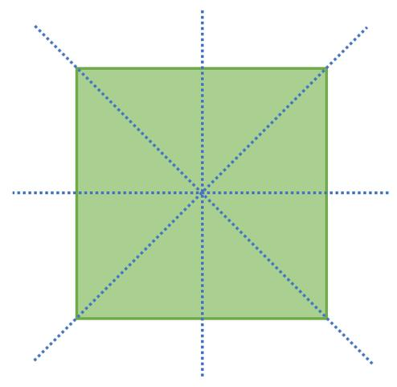
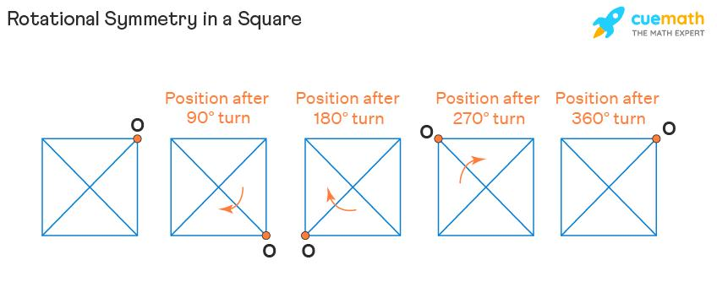
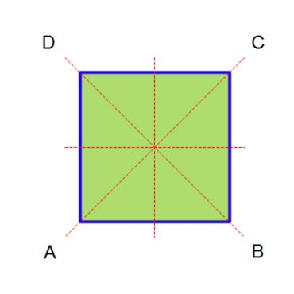
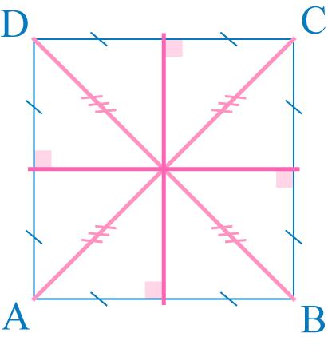
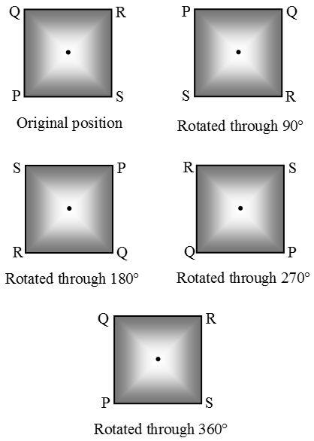

Lines of Symmetry
# Source: AI Source: Provided by: [Data Path: Persons Table -> ID Column: 1, Name_En Column: Motasem Essam] -> From: [ChatGPT] on [7/25/2026]
A square has 4 lines of symmetry:
- Two diagonals.
- Two lines through the midpoints of opposite sides.
Therefore:
$$\boxed{4\text{ lines of symmetry}}$$

Rotational Symmetry
# Source: AI Source: Provided by: [Data Path: Persons Table -> ID Column: 1, Name_En Column: Motasem Essam] -> From: [ChatGPT] on [7/25/2026]
A square has rotational symmetry of order:
$$\boxed{4}$$
It maps onto itself after rotations of:
$${90}^{∘}, {180}^{∘}, {270}^{∘}, {360}^{∘}$$
The smallest non-zero angle of rotational symmetry is:
$$\boxed{{90}^{∘}}$$

Square and Rectangle
# Source: AI Source: Provided by: [Data Path: Persons Table -> ID Column: 1, Name_En Column: Motasem Essam] -> From: [ChatGPT] on [7/25/2026]
A square is a special type of rectangle.
Both have:
- Four right angles.
- Opposite sides parallel.
- Congruent diagonals.
- Diagonals that bisect each other.
However, a square additionally has:
$$\boxed{\text{All four sides congruent}}$$
Therefore:
$$\boxed{\text{Every square is a rectangle}}$$
but:
$$\boxed{\text{Not every rectangle is a square}}$$

Square and Rhombus
# Source: AI Source: Provided by: [Data Path: Persons Table -> ID Column: 1, Name_En Column: Motasem Essam] -> From: [ChatGPT] on [7/25/2026]
A square is also a special type of rhombus.
Both have:
- Four congruent sides.
- Opposite sides parallel.
- Diagonals that bisect each other.
- Perpendicular diagonals.
A square additionally has:
$$\boxed{\text{Four right angles}}$$
Therefore:
$$\boxed{\text{Every square is a rhombus}}$$
but:
$$\boxed{\text{Not every rhombus is a square}}$$

Square and Parallelogram
# Source: AI Source: Provided by: [Data Path: Persons Table -> ID Column: 1, Name_En Column: Motasem Essam] -> From: [ChatGPT] on [7/25/2026]
A square is a special type of parallelogram because:
$$AB∥CD$$
and
$$AD∥BC$$
It also satisfies the general parallelogram properties:
- Opposite sides are congruent.
- Opposite angles are congruent.
- Diagonals bisect each other.

Classification Relationship
# Source: AI Source: Provided by: [Data Path: Persons Table -> ID Column: 1, Name_En Column: Motasem Essam] -> From: [ChatGPT] on [7/25/2026]
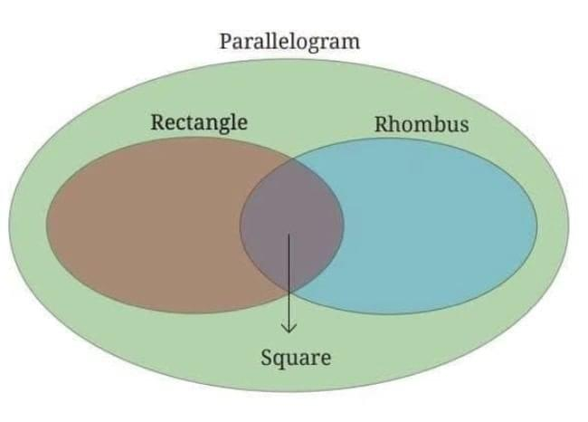
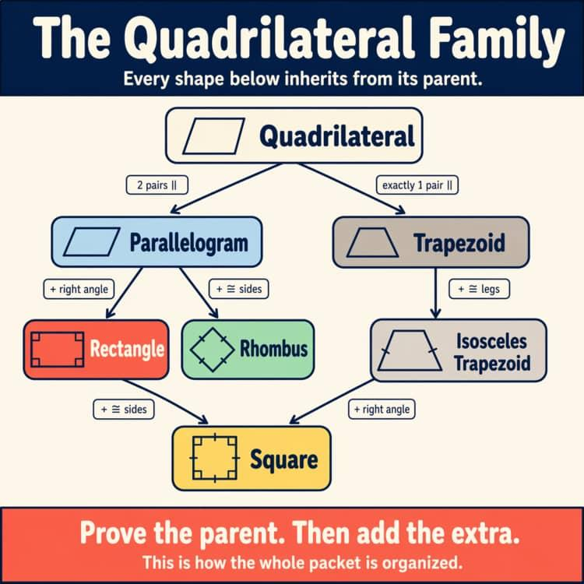
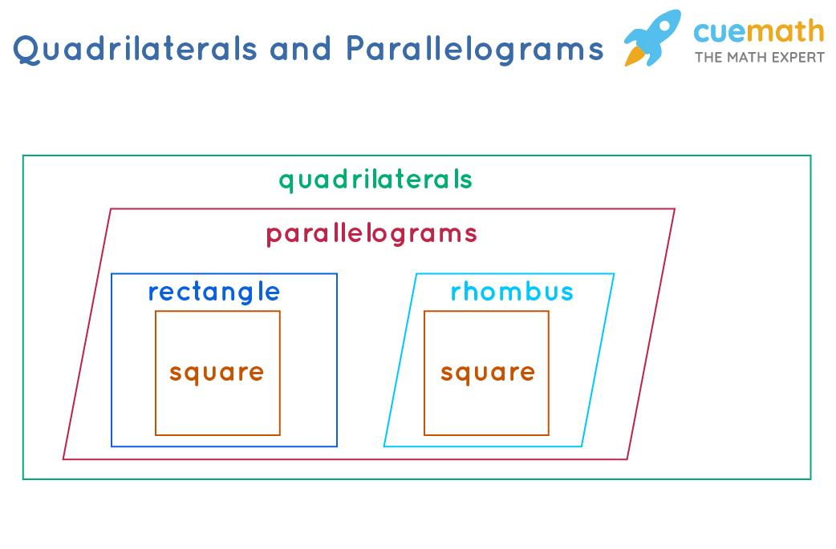
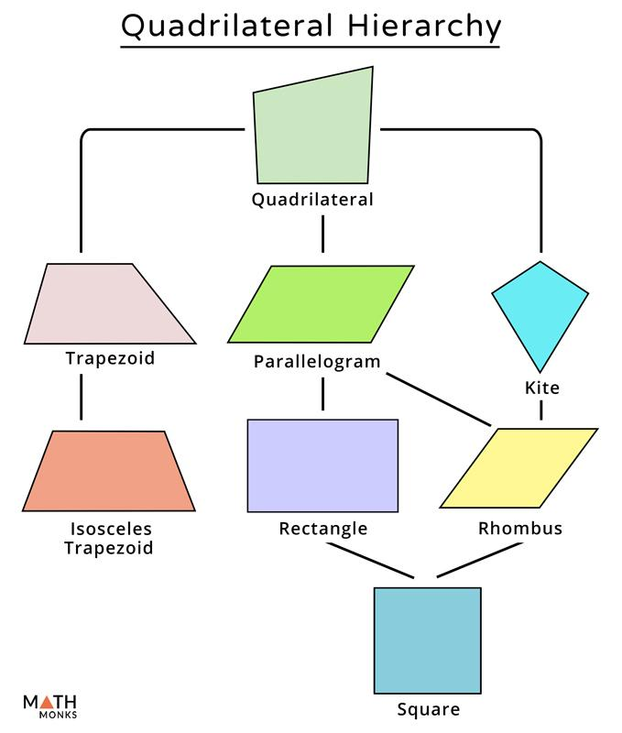
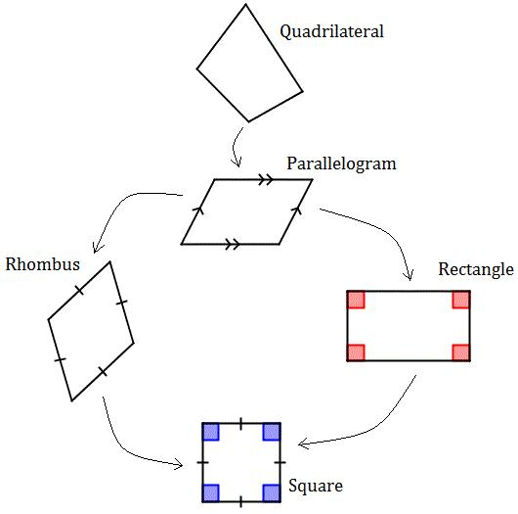
The classification can be represented as:
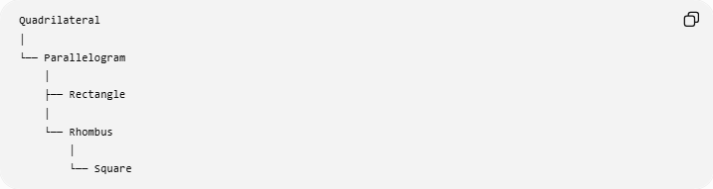
Quadrilateral
│
└── Parallelogram
│
├── Rectangle
│
└── Rhombus
│
└── Square
More precisely, the square belongs simultaneously to:
$$\boxed{\text{Quadrilateral}→\text{Parallelogram}→\text{Rectangle and Rhombus}}$$

Important Theorems and Properties
# Source: AI Source: Provided by: [Data Path: Persons Table -> ID Column: 1, Name_En Column: Motasem Essam] -> From: [ChatGPT] on [7/25/2026]
1. Square Diagonal Theorem
The diagonals of a square are congruent and perpendicular, and they bisect each other.
$$\boxed{AC=BD} \\ \boxed{AC⊥BD}$$
2. Diagonal Bisector Property
If the diagonals intersect at $O$:
$$\boxed{AO=OC} \\ \boxed{BO=OD}$$
3. Diagonal Angle-Bisector Property
Each diagonal bisects a pair of opposite angles.
4. Pythagorean Relationship
The diagonal, side, and side form a right triangle:
$$d^{2}=s^{2}+s^{2}$$
Therefore:
$$\boxed{d=s\sqrt{2}}$$

Examples

Example 1: Find the Perimeter
# Source: AI Source: Provided by: [Data Path: Persons Table -> ID Column: 1, Name_En Column: Motasem Essam] -> From: [ChatGPT] on [7/25/2026]
A square has side length $9$cm.
$$P=4s \\ P=4\left(9\right) \\ \boxed{P=36\text{ cm}}$$

Example 2: Find the Area
# Source: AI Source: Provided by: [Data Path: Persons Table -> ID Column: 1, Name_En Column: Motasem Essam] -> From: [ChatGPT] on [7/25/2026]
A square has side length $12$m.
$$A=s^{2} \\ A={12}^{2} \\ \boxed{A=144{\text{ m}}^{2}}$$

Example 3: Find the Diagonal
# Source: AI Source: Provided by: [Data Path: Persons Table -> ID Column: 1, Name_En Column: Motasem Essam] -> From: [ChatGPT] on [7/25/2026]
A square has side length $10$cm.
$$d=s\sqrt{2} \\ d=10\sqrt{2} \\ \boxed{d=10\sqrt{2}\text{ cm}}$$

Example 4: Find the Side from the Diagonal
# Source: AI Source: Provided by: [Data Path: Persons Table -> ID Column: 1, Name_En Column: Motasem Essam] -> From: [ChatGPT] on [7/25/2026]
A square has diagonal:
$$d=8\sqrt{2}\text{ cm}$$
Using:
$$d=s\sqrt{2}$$
we get:
$$8\sqrt{2}=s\sqrt{2}$$
Therefore:
$$\boxed{s=8\text{ cm}}$$

Example 5: Find the Area from the Diagonal
# Source: AI Source: Provided by: [Data Path: Persons Table -> ID Column: 1, Name_En Column: Motasem Essam] -> From: [ChatGPT] on [7/25/2026]
A square has diagonal $14$cm.
$$A=\frac{d^{2}}{2} \\ A=\frac{{14}^{2}}{2} \\ A=\frac{196}{2} \\ \boxed{A=98{\text{ cm}}^{2}}$$

Comparison with Other Quadrilaterals
# Source: AI Source: Provided by: [Data Path: Persons Table -> ID Column: 1, Name_En Column: Motasem Essam] -> From: [ChatGPT] on [7/25/2026]
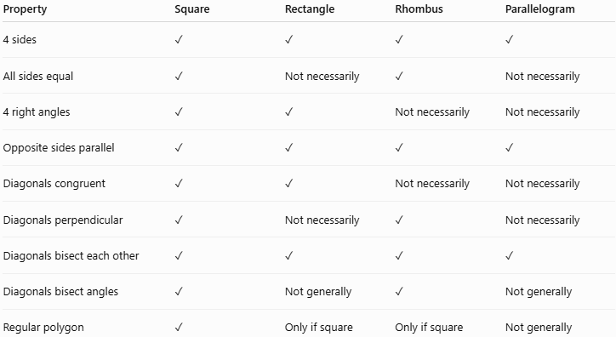
Property | Square | Rectangle | Rhombus | Parallelogram
4 sides | ✓ | ✓ | ✓ | ✓
All sides equal | ✓ | Not necessarily | ✓ | Not necessarily
4 right angles | ✓ | ✓ | Not necessarily | Not necessarily
Opposite sides parallel | ✓ | ✓ | ✓ | ✓
Diagonals congruent | ✓ | ✓ | Not necessarily | Not necessarily
Diagonals perpendicular | ✓ | Not necessarily | ✓ | Not necessarily
Diagonals bisect each other | ✓ | ✓ | ✓ | ✓
Diagonals bisect angles | ✓ | Not generally | ✓ | Not generally
Regular polygon | ✓ | Only if square | Only if square | Not generally

Real-World Applications
# Source: AI Source: Provided by: [Data Path: Persons Table -> ID Column: 1, Name_En Column: Motasem Essam] -> From: [ChatGPT] on [7/25/2026]
Squares are widely used in:
- Floor and wall tiles.
- Windows.
- Tables and boards.
- Paper and documents.
- Chessboards.
- Grids.
- Pixel-based displays.
- Architectural layouts.
- Engineering drawings.
- Patterns and tessellations.
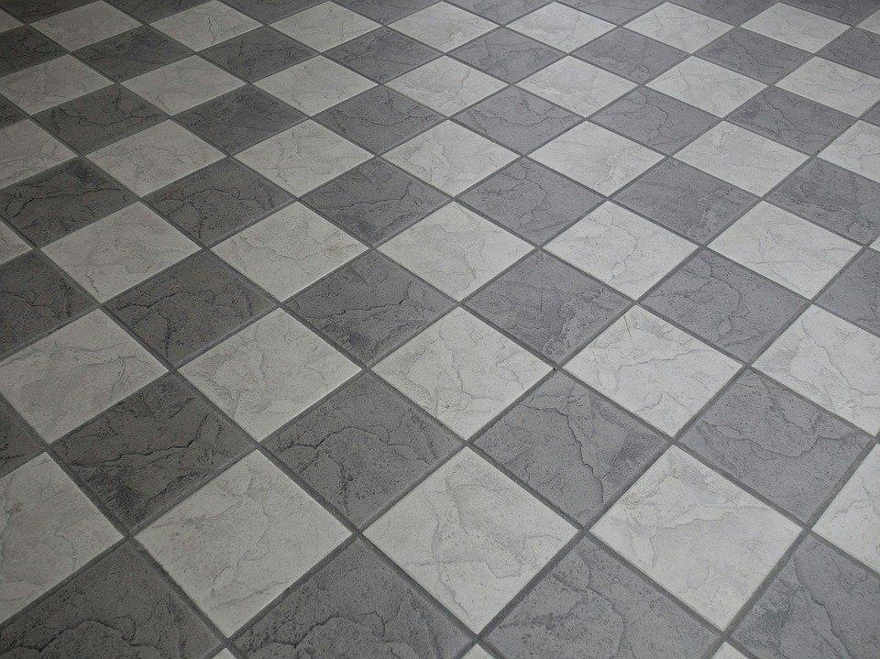
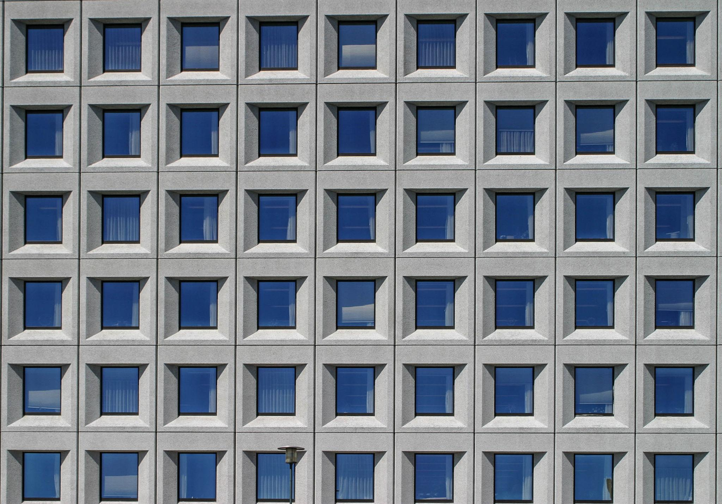
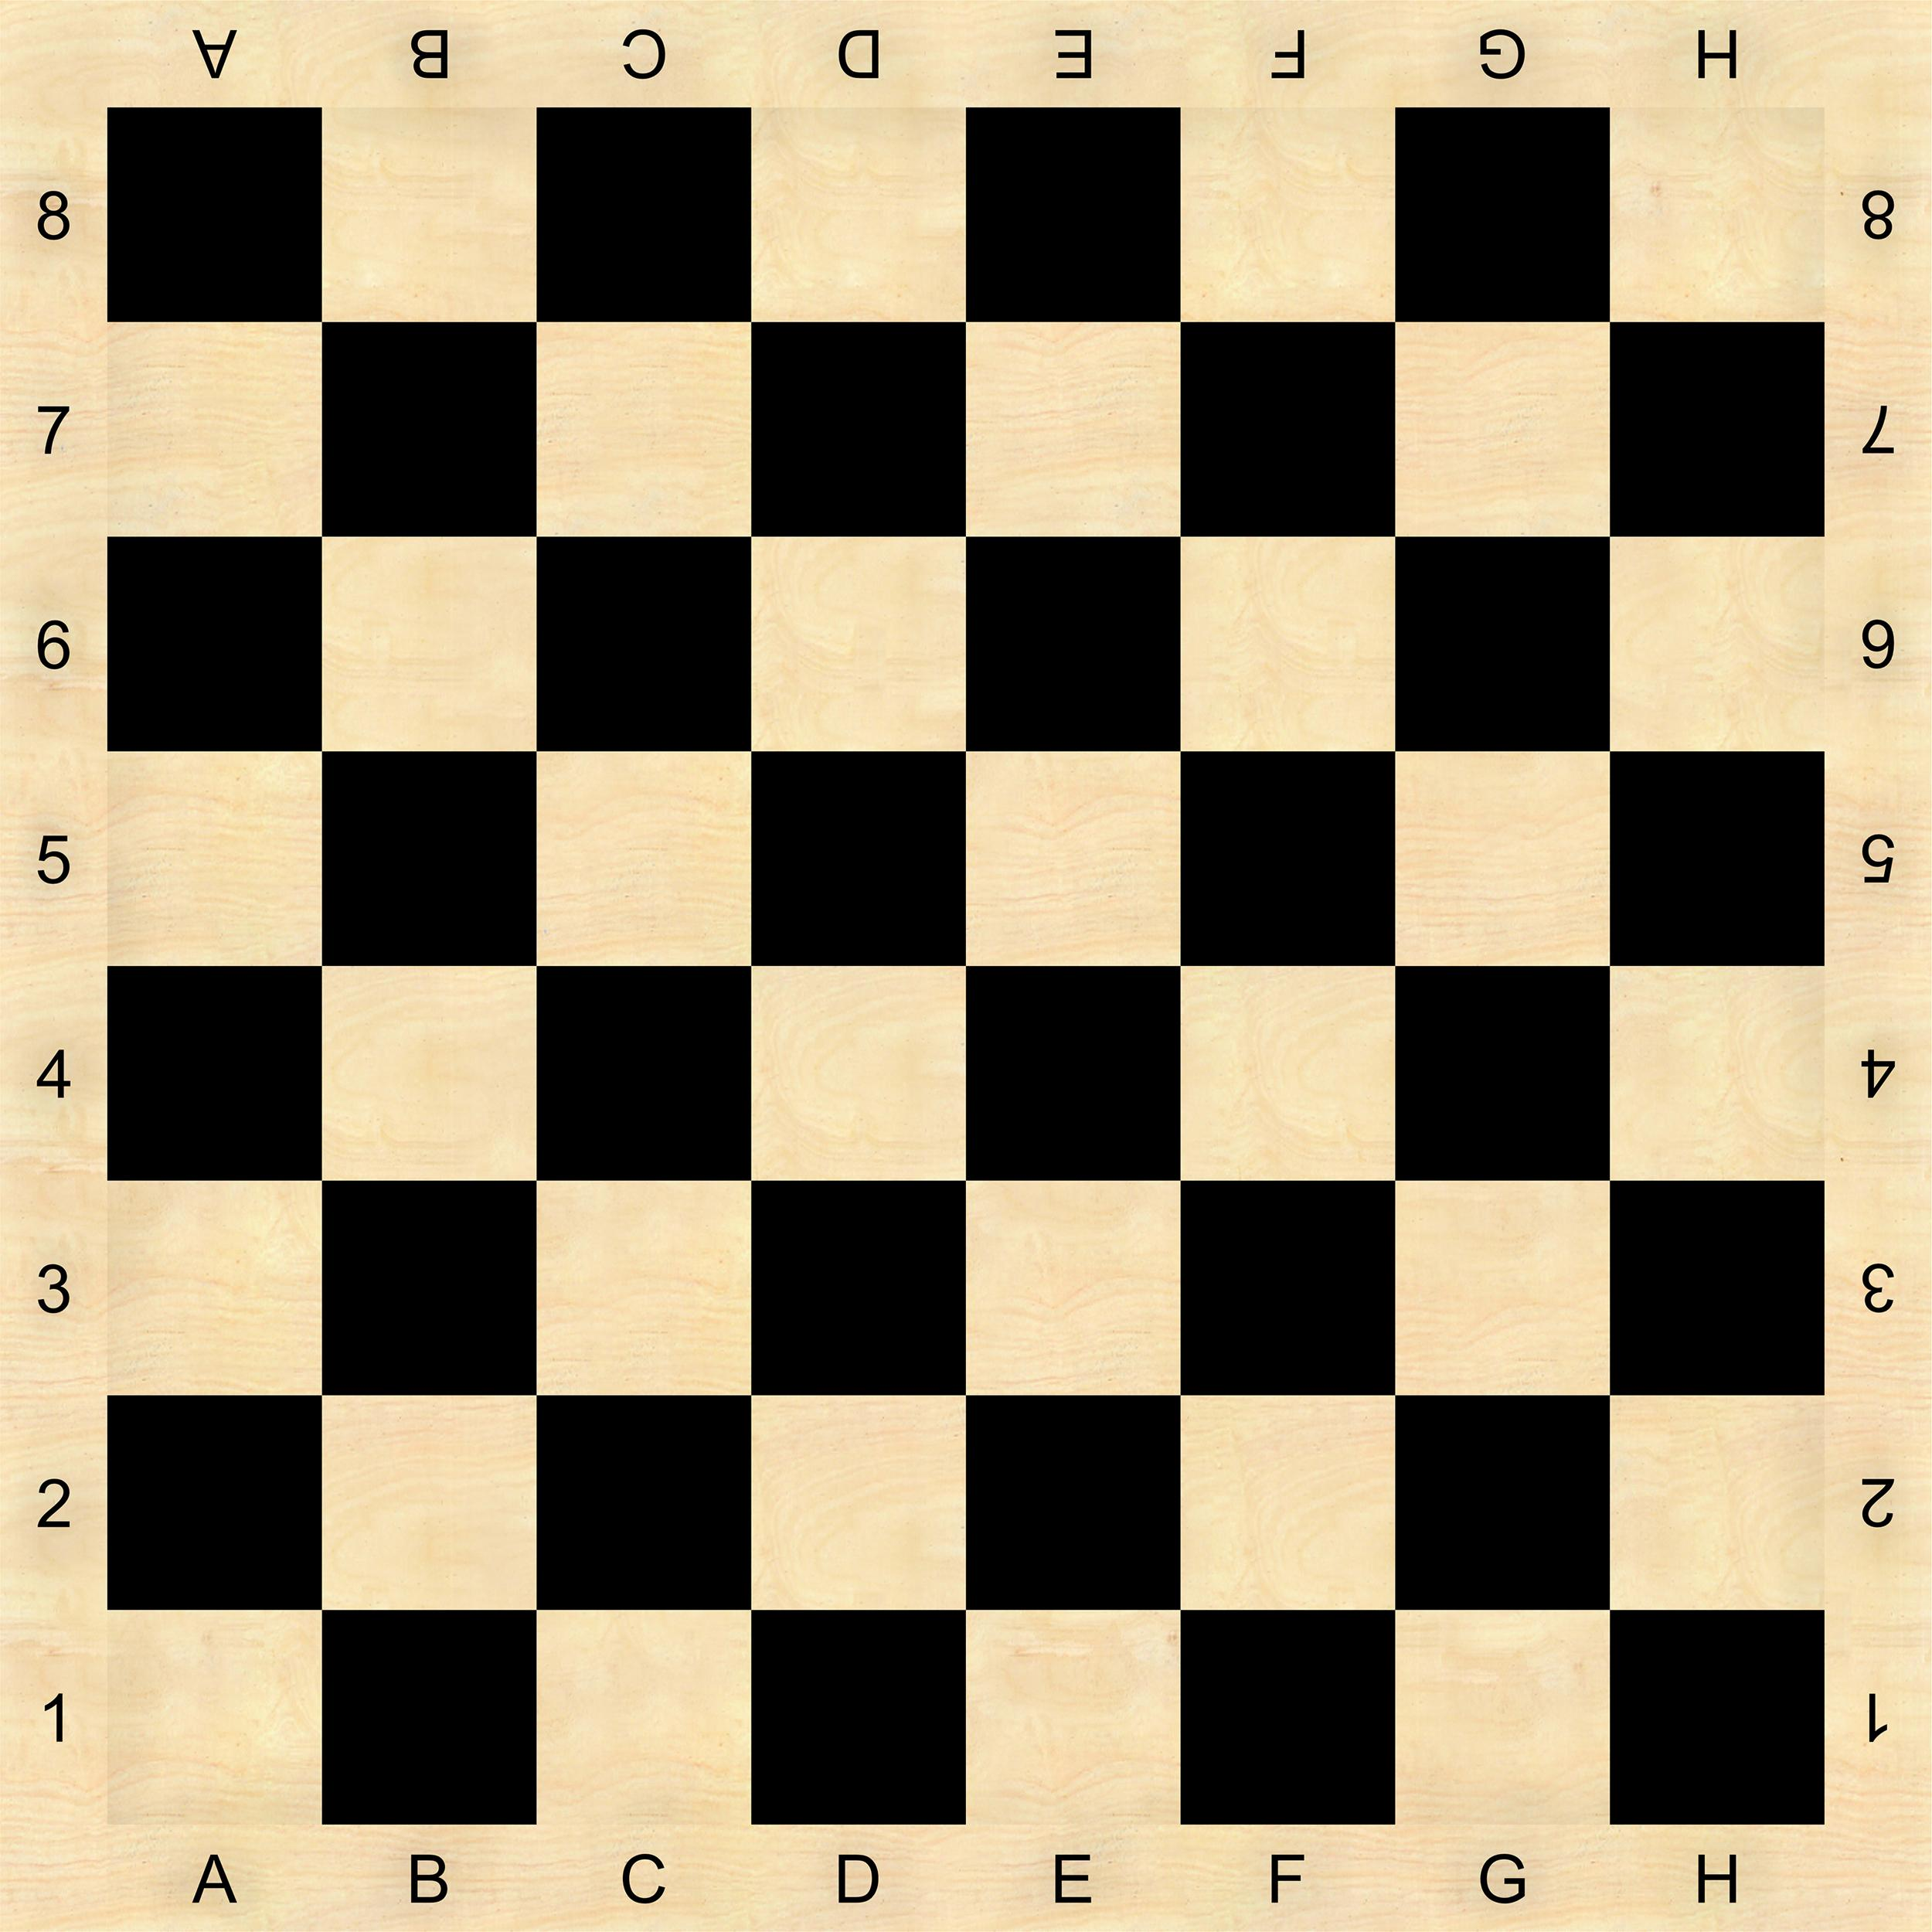
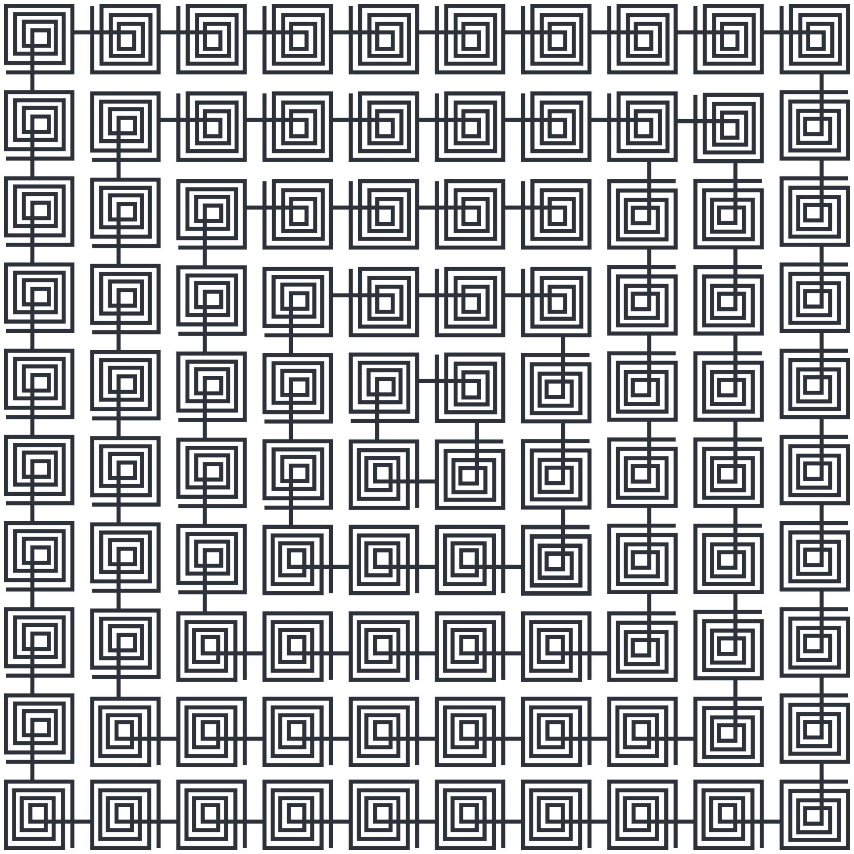

Advantages
# Source: AI Source: Provided by: [Data Path: Persons Table -> ID Column: 1, Name_En Column: Motasem Essam] -> From: [ChatGPT] on [7/25/2026]
- Simple and highly symmetrical.
- Easy perimeter and area calculations.
- Strong relationships between sides, angles, and diagonals.
- Useful for coordinate geometry and geometric constructions.
- Forms the basis of grids, tessellations, and many engineering designs.

Limitations
# Source: AI Source: Provided by: [Data Path: Persons Table -> ID Column: 1, Name_En Column: Motasem Essam] -> From: [ChatGPT] on [7/25/2026]
- It represents only a specific class of quadrilaterals.
- Real-world objects that appear square may not be mathematically exact squares.
- A diagram that looks square does not by itself prove that all sides and angles satisfy the definition.

Key Points
# Source: AI Source: Provided by: [Data Path: Persons Table -> ID Column: 1, Name_En Column: Motasem Essam] -> From: [ChatGPT] on [7/25/2026]
- A square is a quadrilateral with four equal sides and four right angles.
- Each interior angle measures:
$$\boxed{{90}^{∘}}$$
- Perimeter:
$$\boxed{P=4s}$$
- Area:
$$\boxed{A=s^{2}}$$
- Diagonal:
$$\boxed{d=s\sqrt{2}}$$
- Area using the diagonal:
$$\boxed{A=\frac{d^{2}}{2}}$$
- A square has 2 diagonals.
- Its diagonals are:
  - Congruent.
  - Perpendicular.
  - Bisect each other.
  - Angle bisectors.
- A square has 4 lines of symmetry.
- A square has rotational symmetry of order 4.
- Every square is a:
  - Quadrilateral
  - Parallelogram
  - Rectangle
  - Rhombus
  - Regular polygon

Conclusion
# Source: AI Source: Provided by: [Data Path: Persons Table -> ID Column: 1, Name_En Column: Motasem Essam] -> From: [ChatGPT] on [7/25/2026]
A square is one of the most symmetric and important quadrilaterals in plane geometry. It combines the defining properties of a rectangle and a rhombus: it has four equal sides, four right angles, parallel opposite sides, and diagonals that are congruent, perpendicular, and bisect each other. These properties make the square especially important in geometry, measurement, construction, engineering, and mathematical design.

